Some successful stories.
- Baofeng Zhu. Her mother is disabled both mentally and physically. Her father was already 42 when she was born and has chronicle disease. We supported her from first grade through college, and she won National Achievement Award every year in college. She has a good job, a happy family of her own, and can support her parents. Without our support, she might not have gone to high school and definitely would not have gone to college. She wrote an essay after high school graduation (attached).
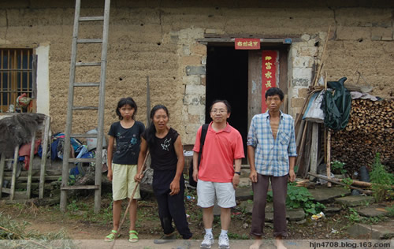
- Limin Yan. She was one of the first students we supported. She lost her father to disease in middle school and lived with her mother who did not have a job. She worked very hard and won National Achievement Awards in college, and went to Zhejiang University for her graduate study. She found a good job at Hang Zhou after her master degree and started to sponsor a poor student through us. She has now a happy family and her own kid.(Photo: with orphans when she was in graduate school)
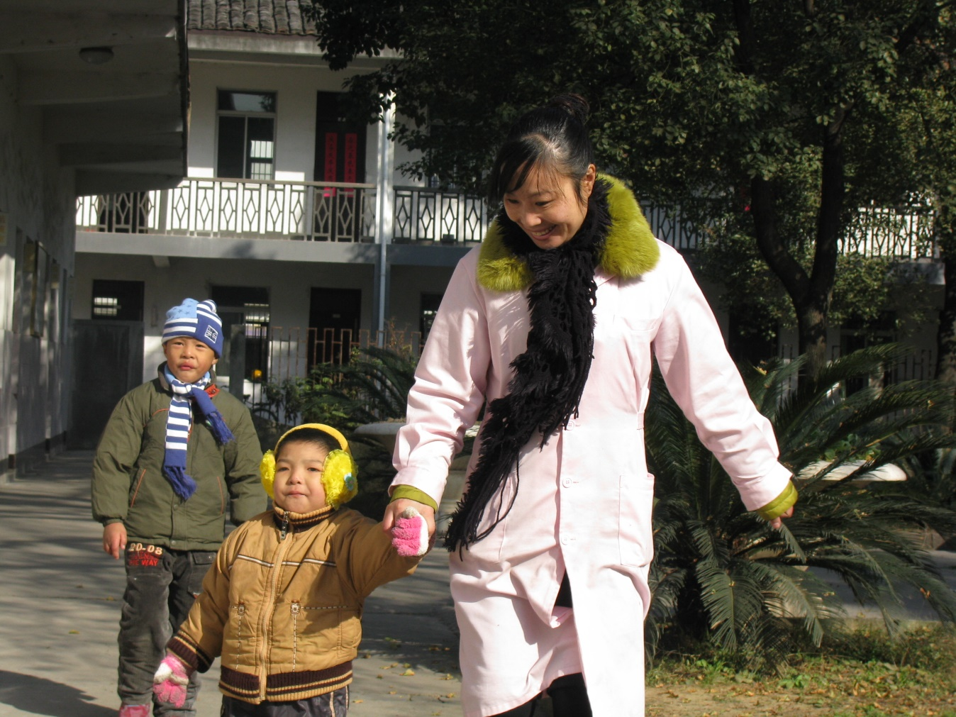
- Lu Wan. She lost her parents while a little kid. She lived with her grandparents in a village. We support her from first grade to college. She only got into three year college but was extremely successful in college. Not only did she upgrade to obtain a bachelor degree but also obtained several patents with her invention. She started a car part company with her technology (others’ money) and has done well. She started to support us second year since her graduation.
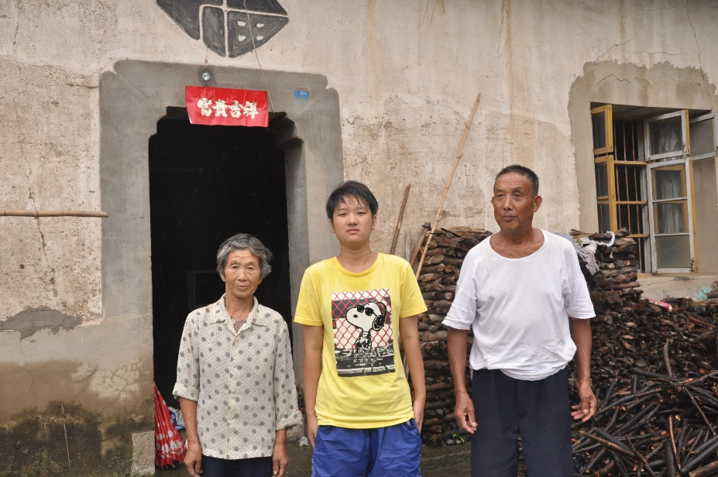
- Xiaojin Shi. She was adopted at birth by her deaf father. She lived with her father and aged grandma of over 80. Both of them loved her a lot but had very limited income. Their house was destroyed in 2013 in a heavy rain. We supported her through high school and college. She went further to Xian Jiao Tong U for her graduate study. She found a job at Huawei after graduation last May.
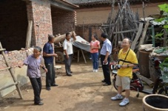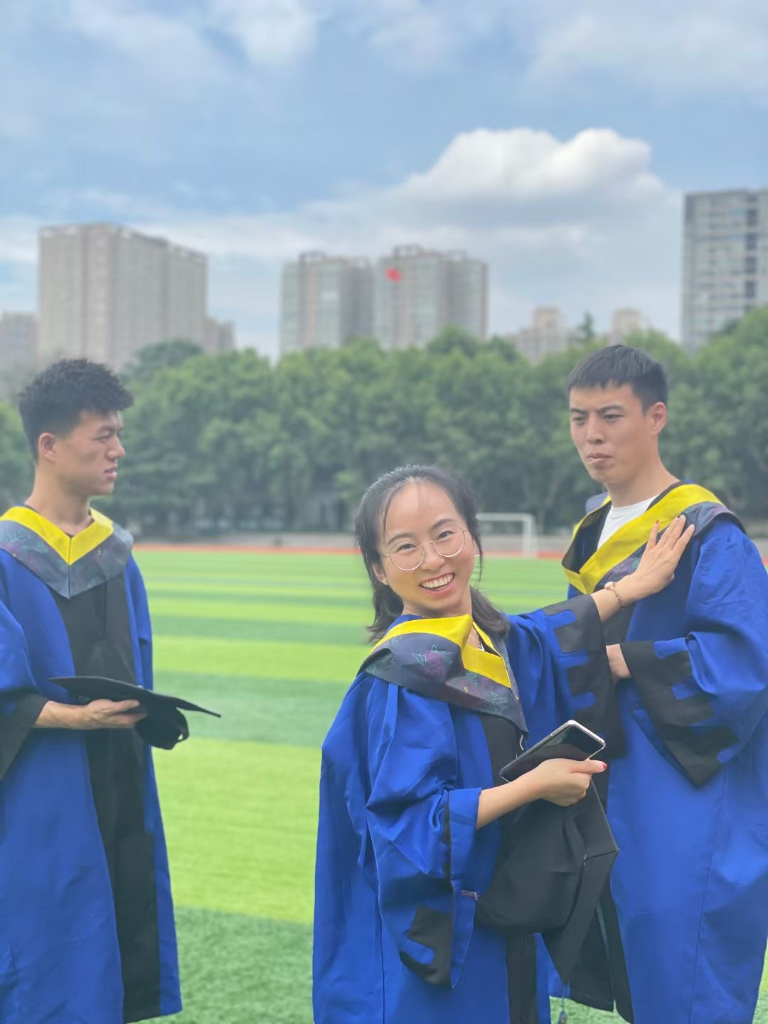
- Huaxin Gong. His father lost one leg due to car accident when he was in middle school. We started to support him since then through college. He was an outstanding student at Zhejiang University and got admitted to Stanford U for his PhD study after graduation from Zhejiang U.
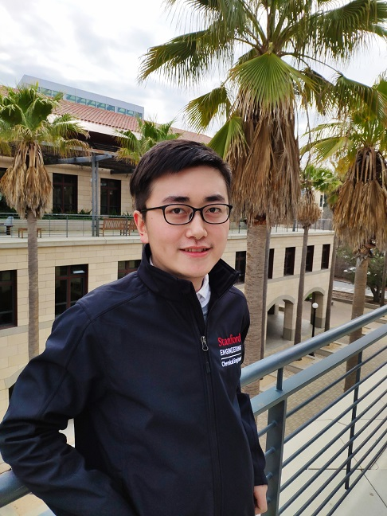
- Weiyong Chen. His father was very smart and hard working but was found to have liver disease when he was in 7th grade. We support him until his high school graduation. He went to a military university with full support. While in school, he established a `微星支教组织‘---organizing college students to teach kids in rural area interesting stuff. He also started to support poor students since his third year in college.
