Six High School Students we supported were admitted to colleges!!!!
(2010)
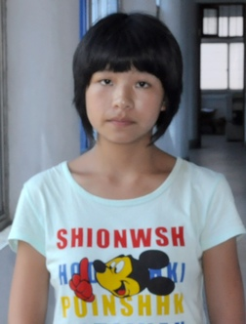 | XueqinTeng was born in 1993 in a small village. Both her parents are disabled: her mother has hearing problem and her father has mental problem. She has a little sister in middle school. She was admitted this year to ZheJiang Industrial and Engineer University (浙江理工大学), majoring in Cartoon (art). Her case is amazing to me in two aspects. The high school he attended is one of the worst in Ningguo and students there do not expect to get to college in general. Second, she got admitted not as a regular student but as an art student. Typically, art is expensive and she can not afford all those private tutoring and help. She still got in, which tells something about her talent and determination. She He has been supported by the Hometown Education Foundation and its partner Zhong Mei Ai Xin since middle school.
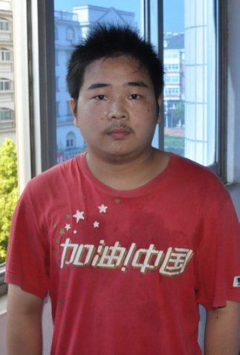 | Jia Wang was born in 1991. He was admitted to the Zhong Shang University (中山大学) with very high score 633 at the college entrance exam. He lives with his parents in a rural area in Ningguo. His father has heart disease. He has been supported by the Hometown Education Foundation and its partner Zhong Mei Ai Xin since middle school.
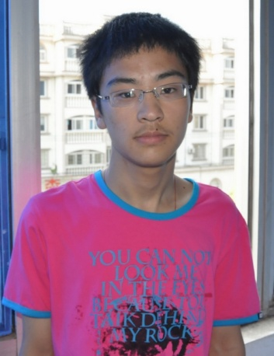 | Qin Yang was born in 1992. This year, he was admitted to the HuZhou University (福州大学) with high score 595 at the college entrance exam. His parents divorced in 2007, and he lives with his mother. His father does not pay child support. His mother earns about 1000 yuan a month working at a local factory. He has been supported by the Hometown Education Foundation and its partner Zhong Mei Ai Xin since 2008.
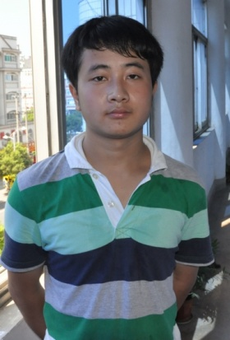 | Miao Xie has been supported by the Hometown Education Foundation since 2005. His father is very sick and can not work. All depend his mother’s work at the farm. He got 593 in this year’s college entrance exam and was admitted to the Xian University of Science and Construction (西安建筑科技大学).
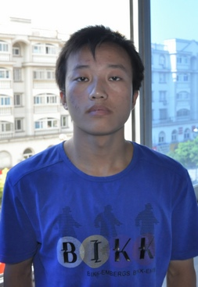 | Zhiyuan Wang was born in 1993 in a very rural village. When he was 8, his father had brain bleeding, and his mother had to stay in hospital to take care of his father. He and his older brother were left at home to take care of themselves. It made him grow up quickly. He was admitted to Anhui Agriculture University (安徽农业大学) with high score of 542. He has been supported by the Hometown Education Foundation and its partner Ningguo City ZHong Mei Ai Xin since middle school.
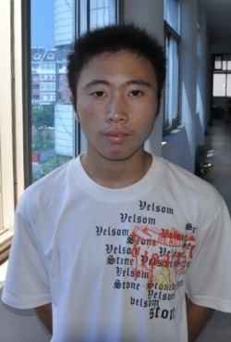 | Dongyang Qiu was born in 1991 also in a very rural area. He lives with parents and grandma. His father is already over 60, and his mother is disabled. His grandma is 89. Both his parents are pure farmers. He was admitted to the Anhui Institute of Science and Technology with high score 525. He has been supported by the Hometown Education Foundation and its partner Ningguo City ZHong Mei Ai Xin since middle school.

